**Machine Learning**

**Lab Manual**



**Gurpreet Singh Sahni**

**01676802717**

**CSE – 3**

**Problem Statement:**

Classification of cancer with the help of Decision Trees.

**Algorithm of ML Problem:**

Decision Trees:

Decision tree models where the target variable uses a discrete set of values are classified as Classification Trees.

In these trees, each node, or leaf, represent class labels while the branches represent conjunctions of features leading to class labels.

A decision tree where the target variable takes a continuous value, usually numbers, are called Regression Trees.

The two types are commonly referred to together at CART (Classification and Regression Tree).

**Program Code Snippets:**

**Loading Dataset:**

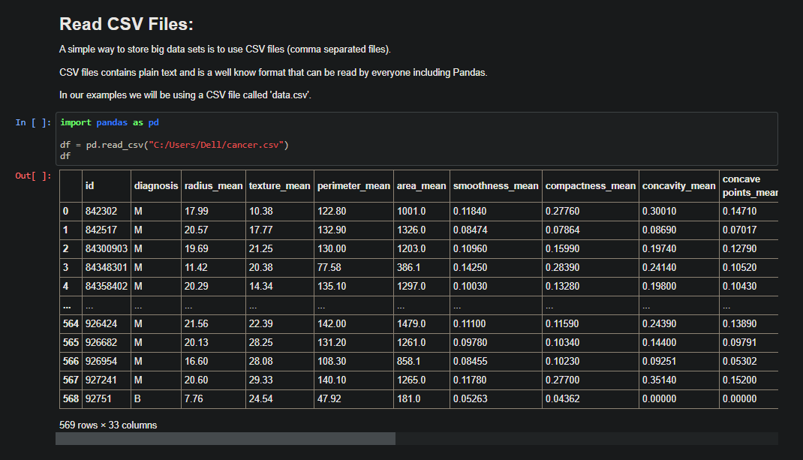

**Pre-processing of Dataset:**

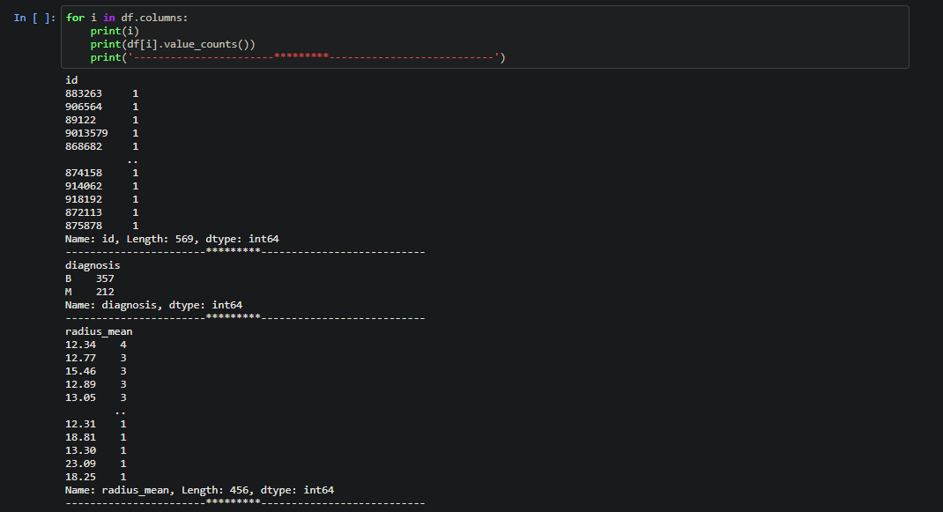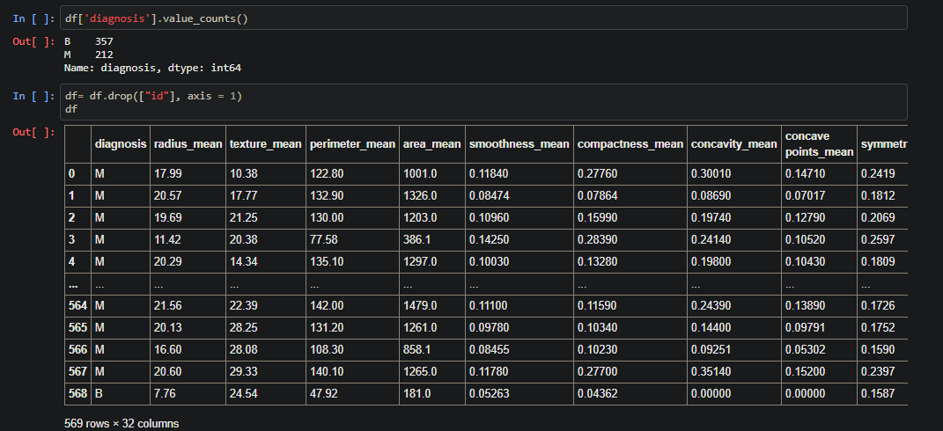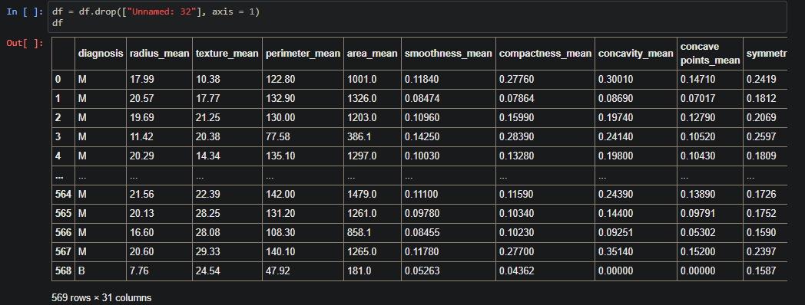

**Visualisation:**

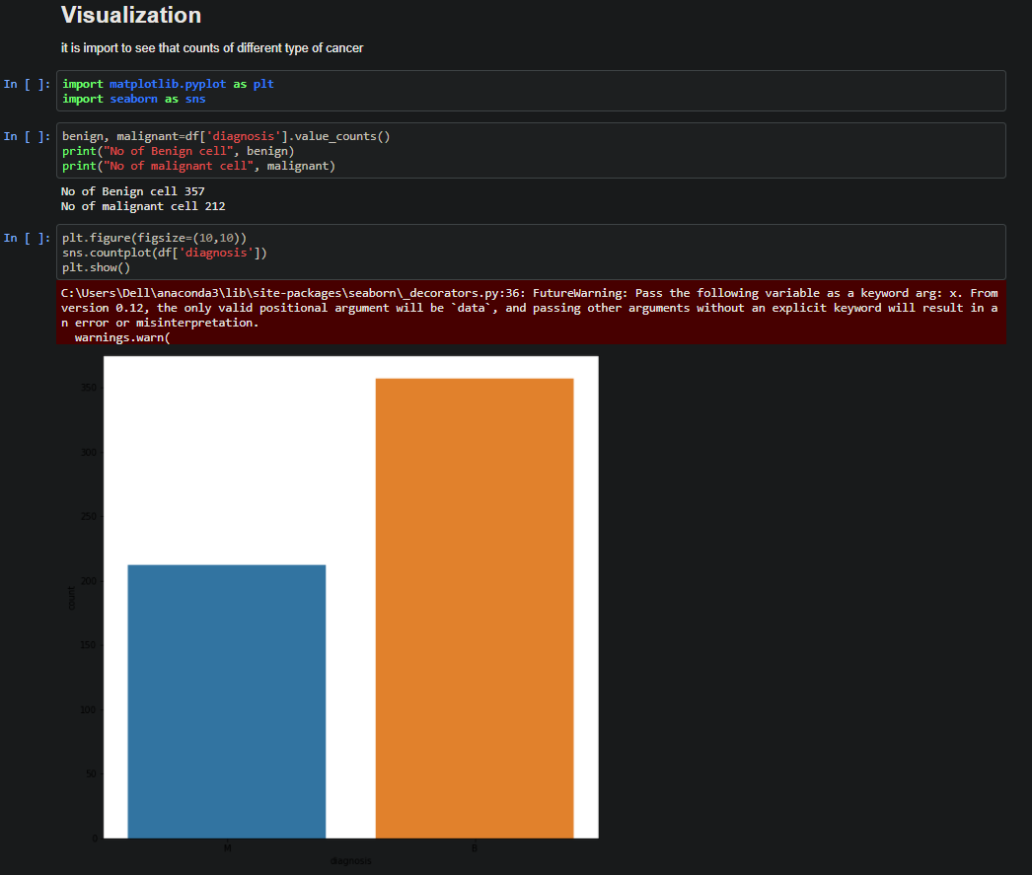

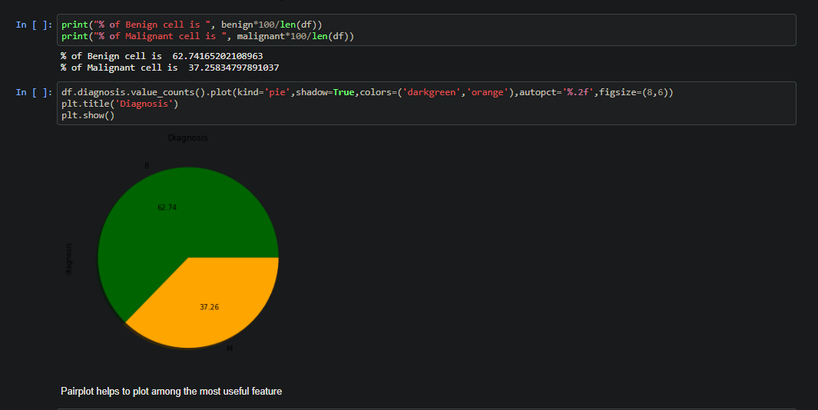

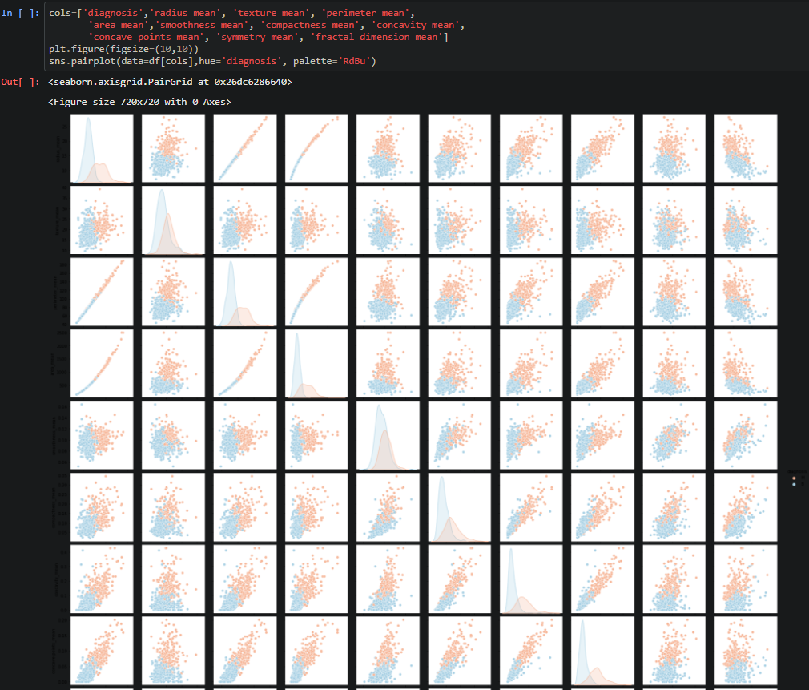

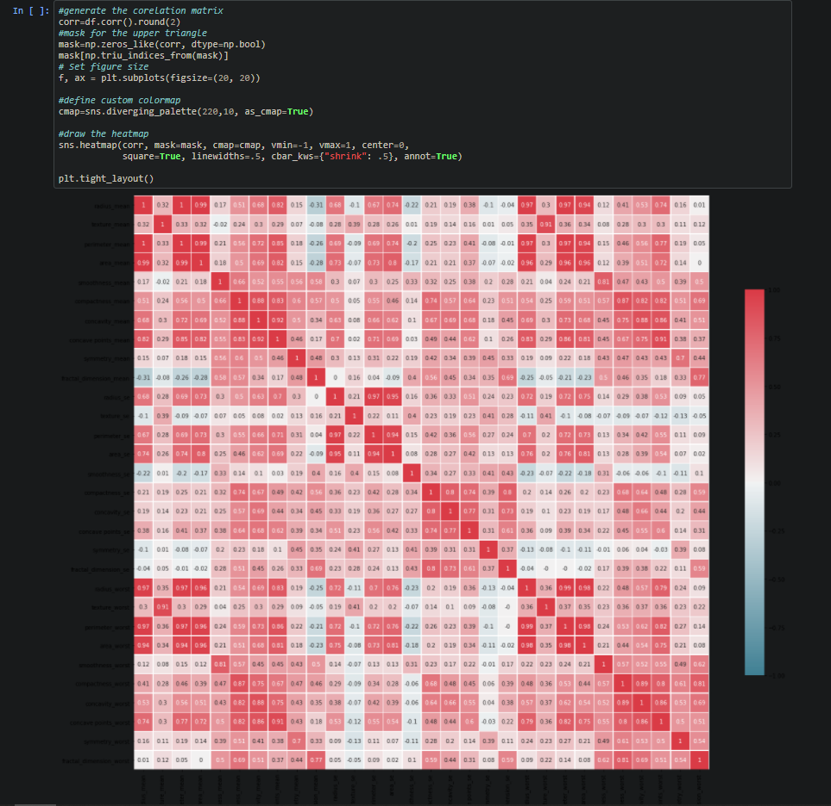

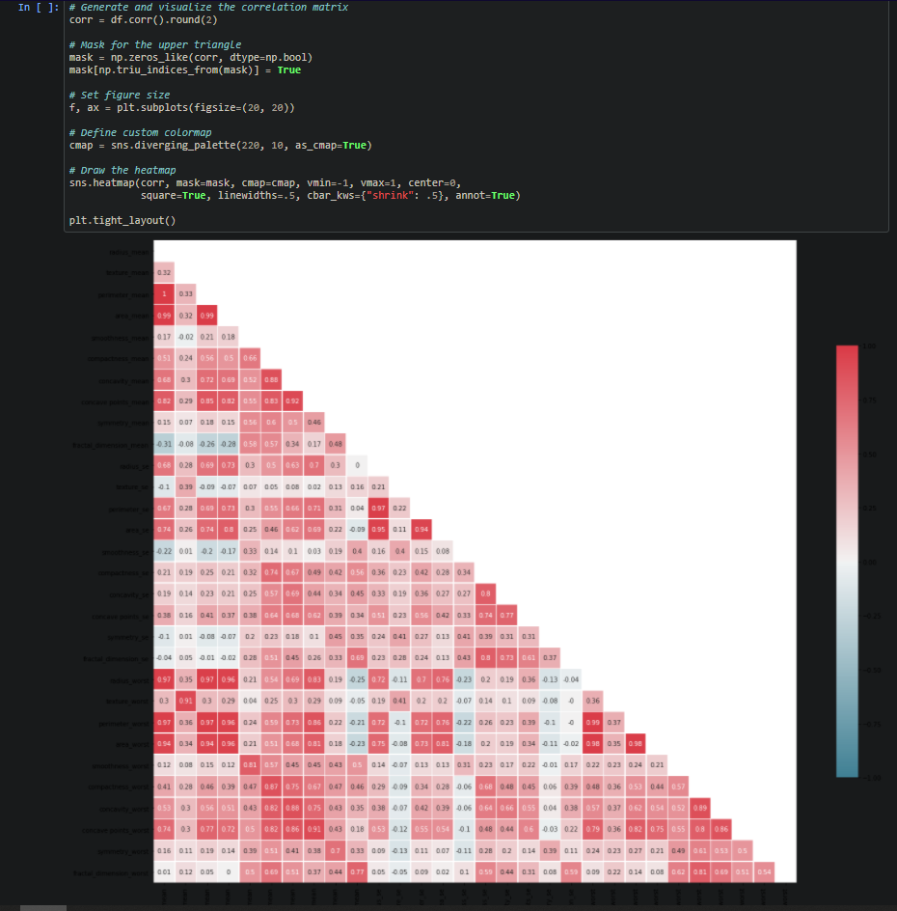

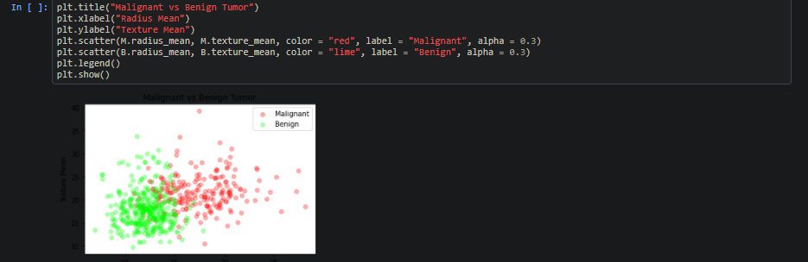

**ML algorithm implementation of prediction or comparison:** 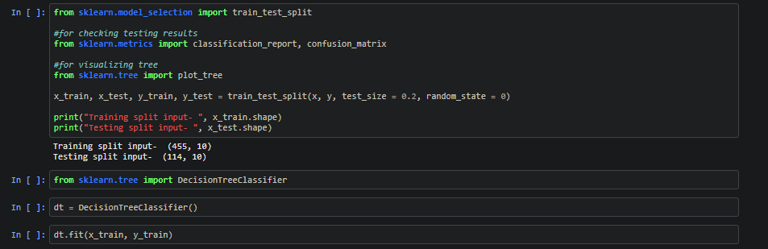

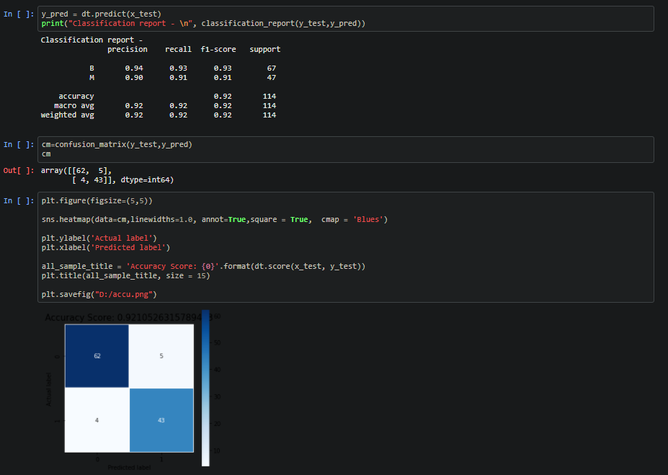

**Confusion Matrix:**



**Final Decision Tree Graph:**

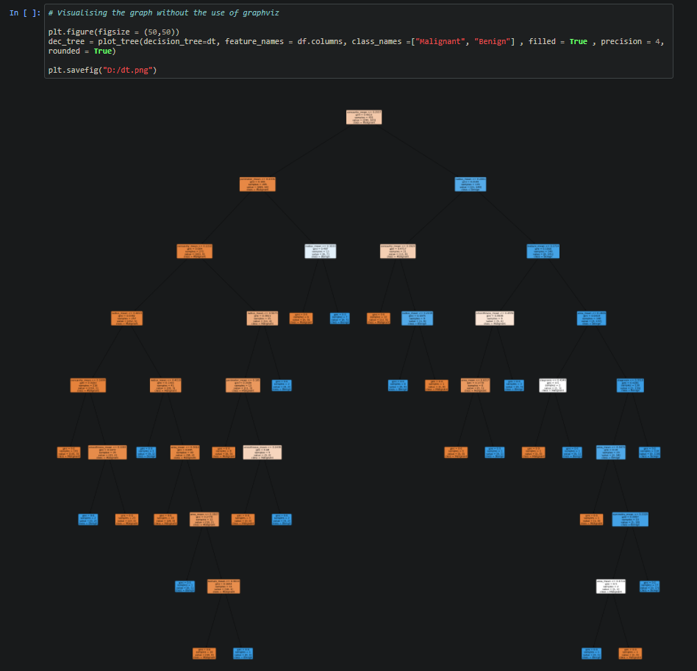

**GitHub Link:**

[**https://github.com/gurpreetsahni/ML-Class/blob/main/Lab1_DT.ipynb**](https://github.com/gurpreetsahni/ML-Class/blob/main/Lab1_DT.ipynb)